Builder Pattern

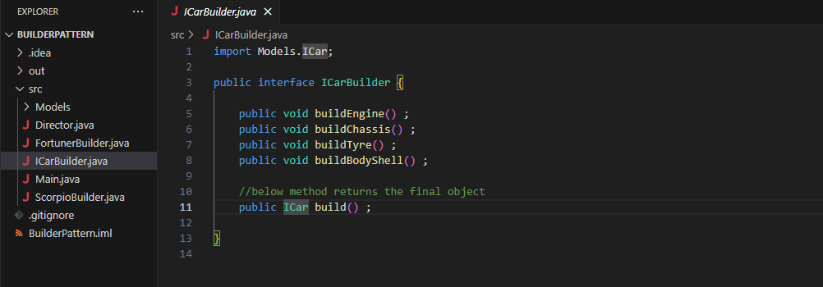

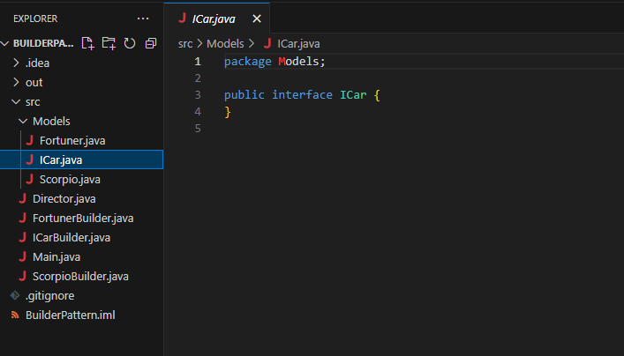

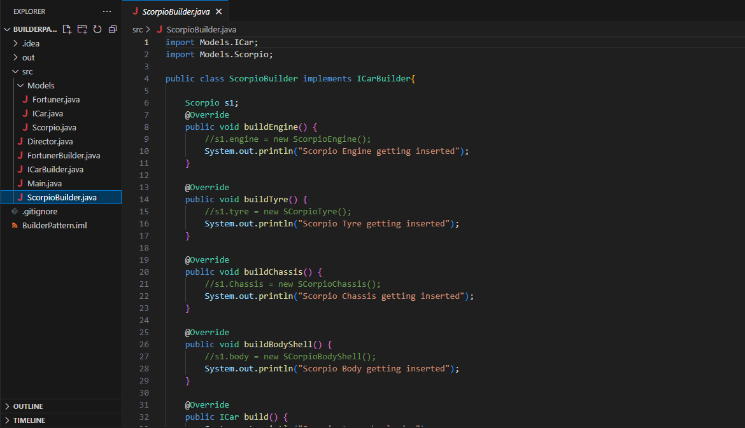

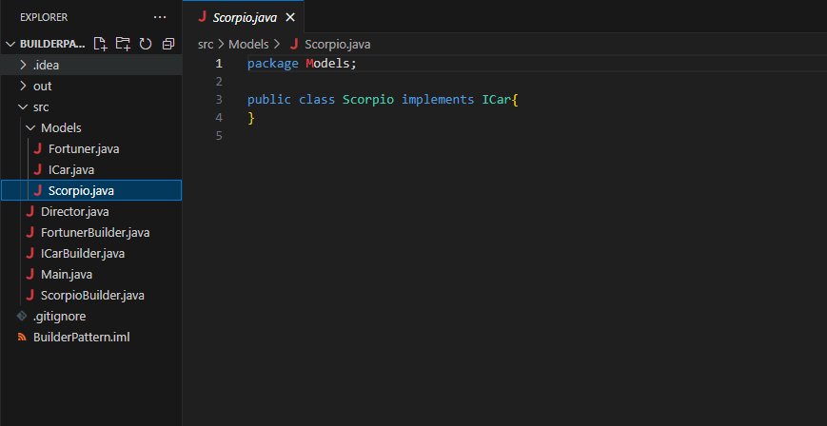

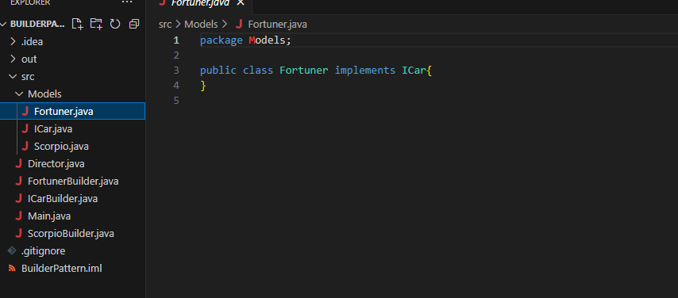

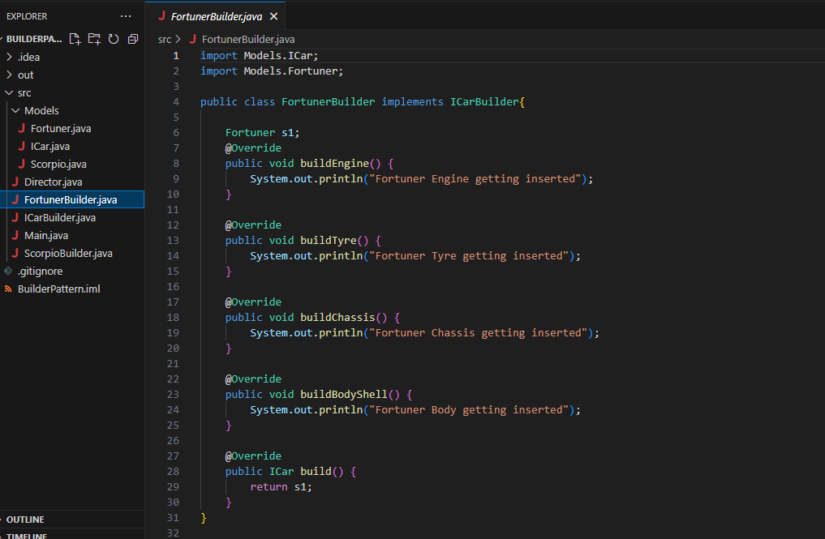

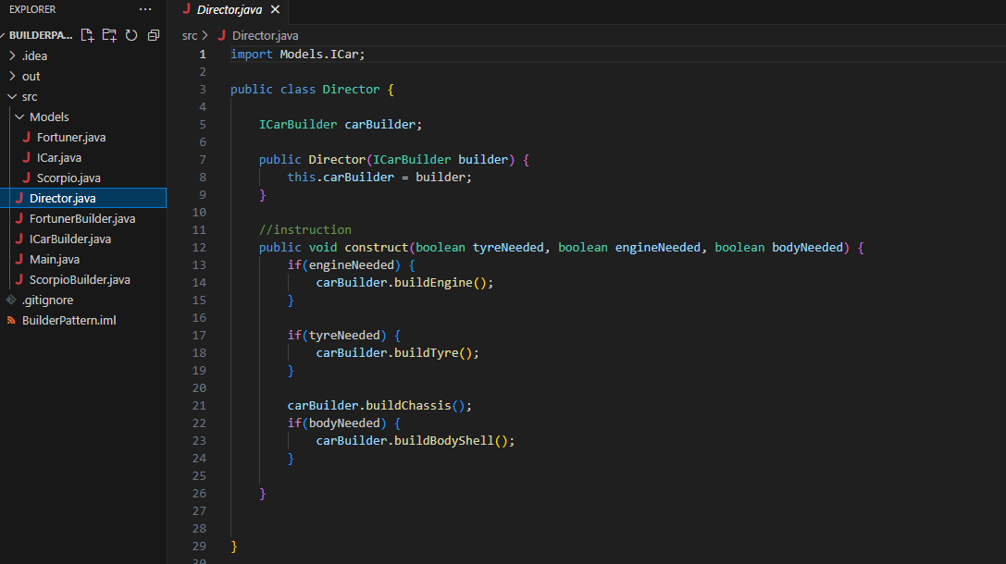

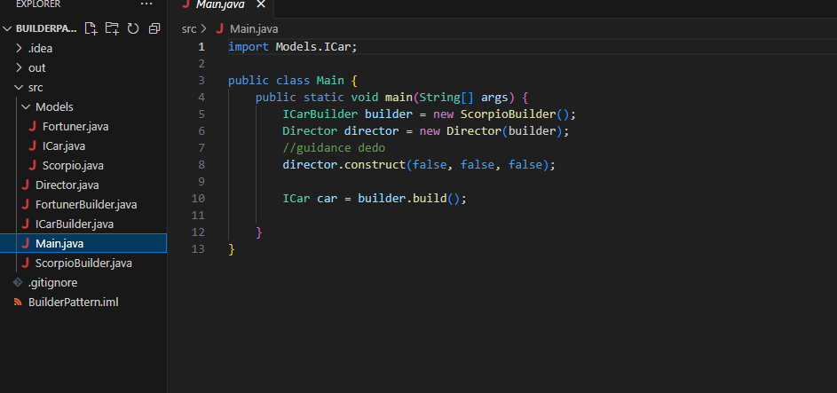

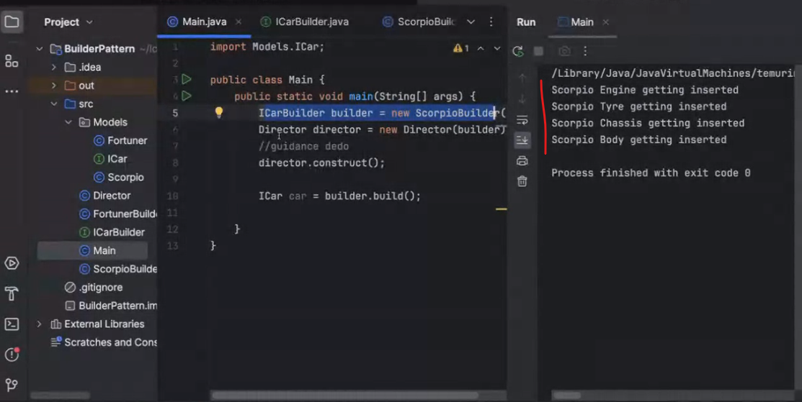

Singleton

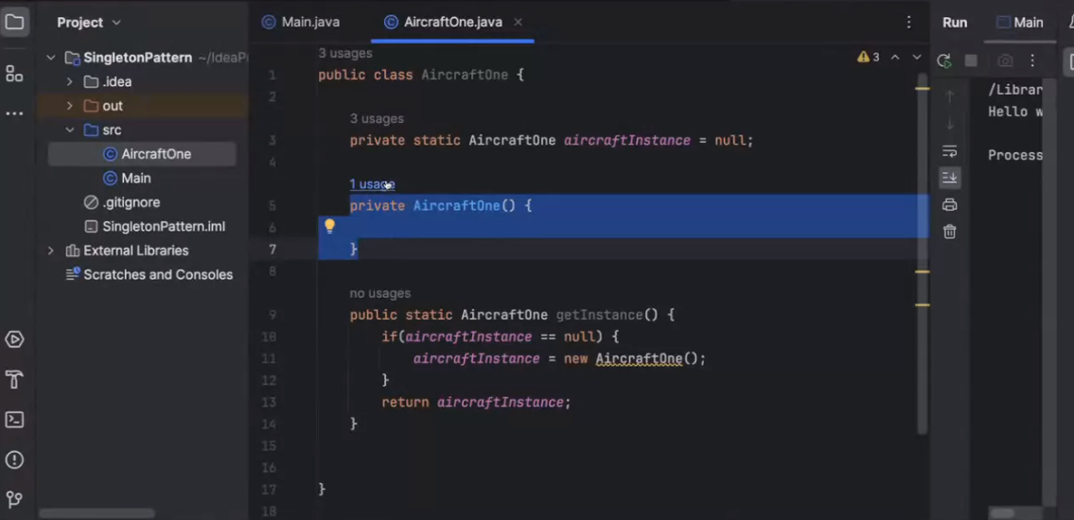

Agar object create nahi hai toh create kar do aur uske baad usko return kar do,

Agar pahle se object bana tha usko return kar do.

Singleton mai class ka ek object banta hai

---

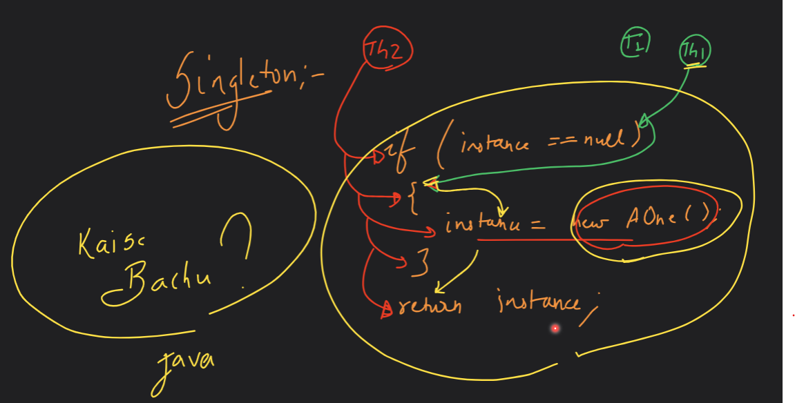

Iss mai code nahi chalega ,kyuki singleton mai two object ban rahe hai.

How to solve when two object created ?

1. To make the Singleton pattern thread-safe, you can modify the method to use synchronisation. method is declared as synchronized , which ensures that only one thread can enter the method at a time

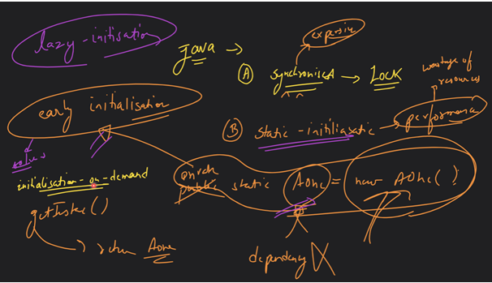

----

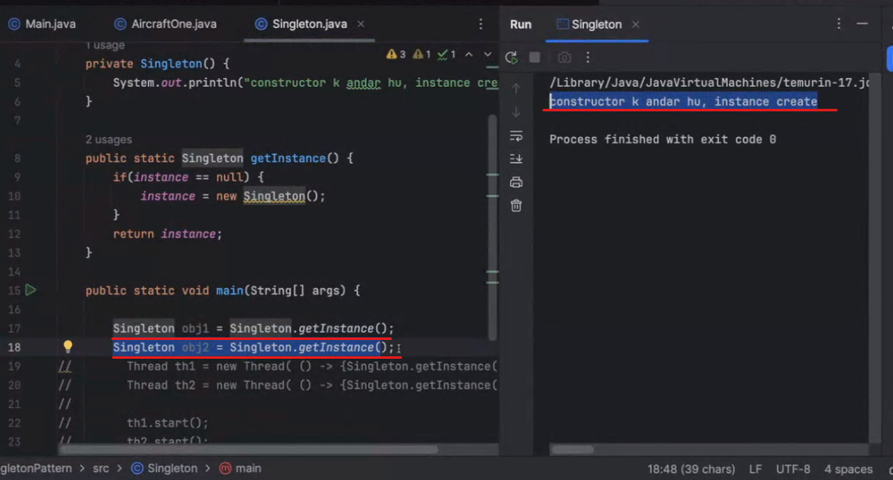

Two object bana hai lekin singleton mai mai ek baar hi object banega…

----

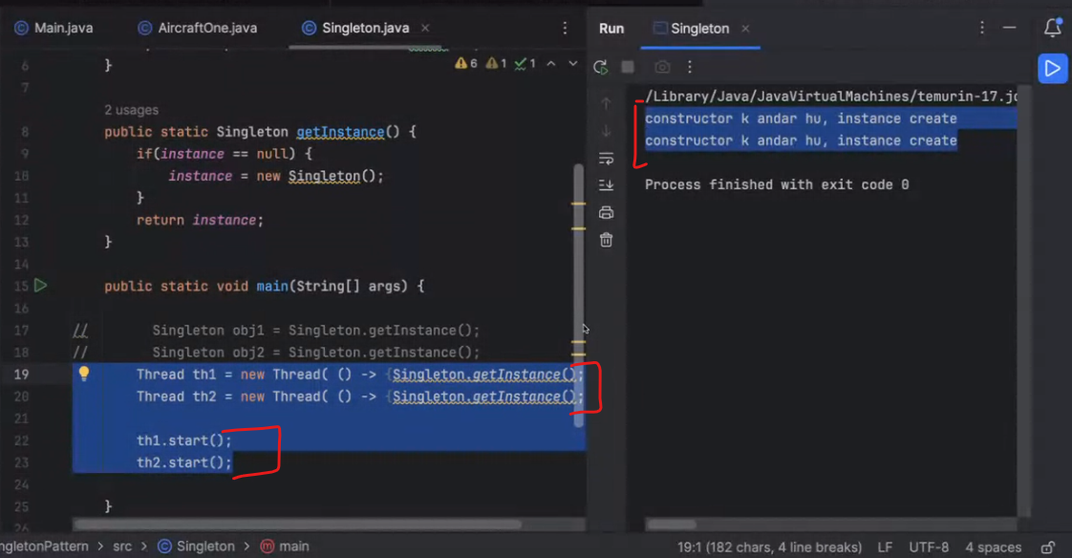

Lekin thread ke case mai two object ban rahe hai singleton ka rule break ho gaya yaha par

Lazy Initialization

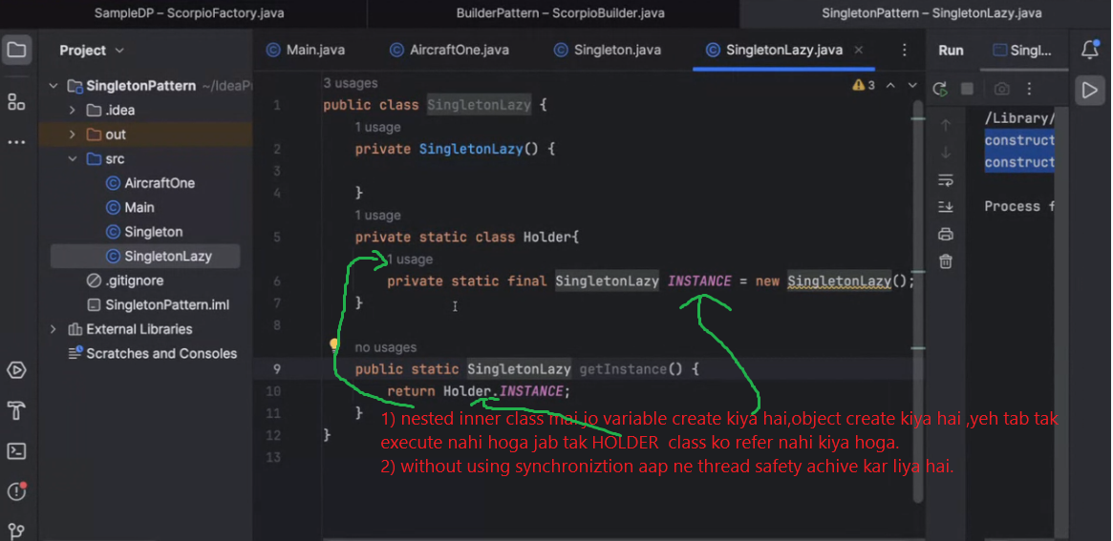

Mayer singleton approach in c++

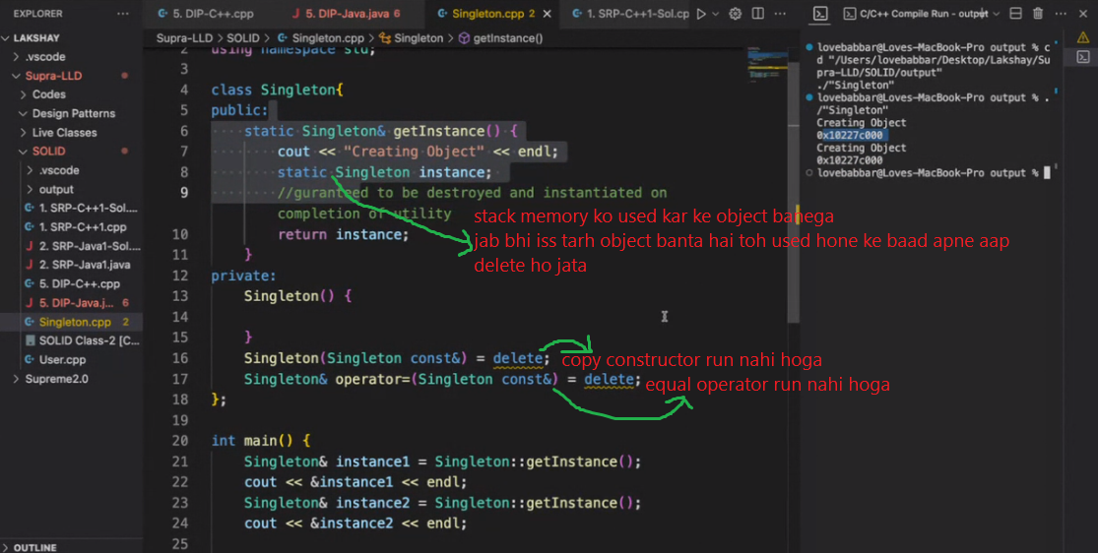

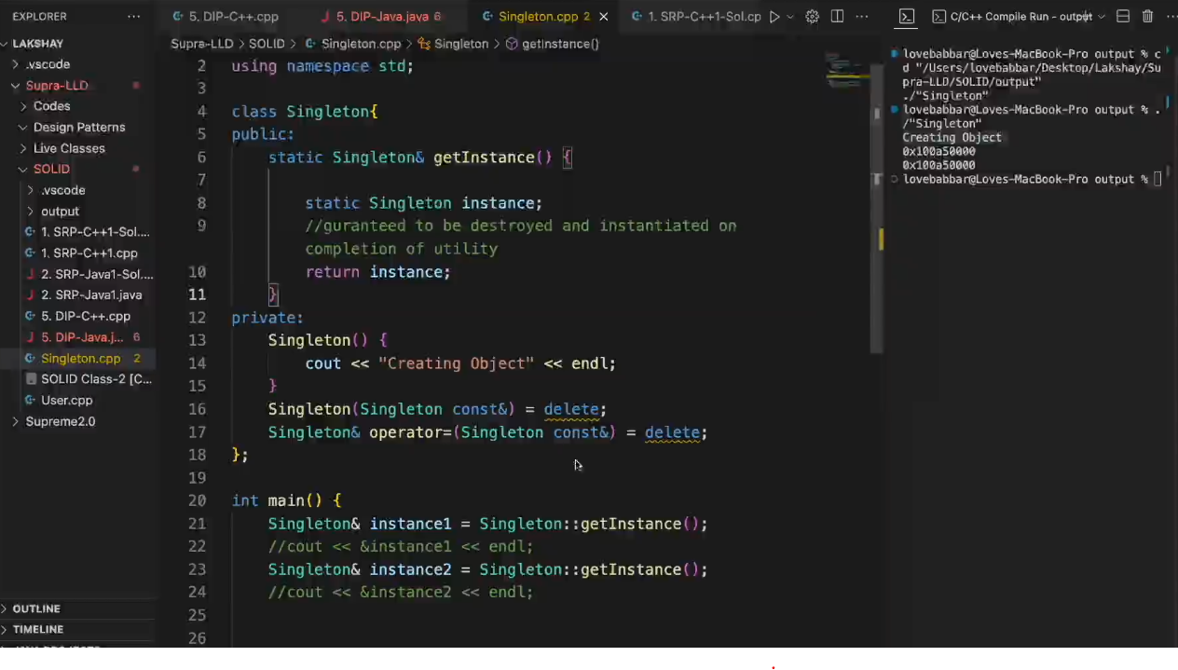

Double checked locking : agar object nahi bana hai toh iss case mai lock lagao.

agar object pahle se bana hai toh iss case mai lock mat lagao

